Assignment 2: SQC & OR

Formulation of Trial Control Limits

**SUBHRAJYOTY ROY**

**Roll – BS1613**

**B.Stat. Year III**

**Indian Statistical Institute**

# Question

Data were obtained from a process that machines cylinder bores in an engine block. The inside diameter of the cylinder bore was measured following the boring operation. Measurements were made to 1/10,000 of an inch. Sample of size $n=5$ were taken to obtain some data to initiate $\overline{X}$ and $R$ control charts for the process. The samples were taken roughly every half-hour. The sample measurements were all taken on the same cylinder (position-wise) in the block. The results of the first 35 samples are shown in Table 1. The actual measurements are of the form 3.5205, 3.5202, 3.5204, and 3.5209 inches, and so on. The table provides only the last three digits in the measurement. Determine the trial control limits for the process.

## Solution

From the given table containing the sampled data, we obtain $\overline{X}$ and $R$ for each of the subgroups (i.e. for each of the shifts).

|  |  |  |  |  |  |  |  |  |  |
| --- | --- | --- | --- | --- | --- | --- | --- | --- | --- |
| **Table 1: Cylinder Boring Process Data** | | | | | | | | | |
| **Time** | **Sample** | **1** | **2** | **3** | **4** | **5** | **Remarks** | **X(bar)** | **Range** |
| 8:00 AM | 1 | 205 | 202 | 204 | 207 | 205 | Startup of boring station | 3.52046 | 0.0005 |
| 8:30 AM | 2 | 202 | 196 | 201 | 198 | 202 |  | 3.51998 | 0.0006 |
| 9:00 AM | 3 | 201 | 202 | 199 | 197 | 196 |  | 3.5199 | 0.0006 |
| 9:30 AM | 4 | 205 | 203 | 196 | 201 | 197 |  | 3.52004 | 0.0009 |
| 10:00 AM | 5 | 199 | 196 | 201 | 200 | 195 |  | 3.51982 | 0.0006 |
| 10:30 AM | 6 | 203 | 198 | 192 | 217 | 196 | Regular operator absent. | 3.52012 | 0.0025 |
| 11:00 AM | 7 | 202 | 202 | 198 | 203 | 202 |  | 3.52014 | 0.0005 |
| 11:30 AM | 8 | 197 | 196 | 196 | 200 | 204 |  | 3.51986 | 0.0008 |
| 12:00 PM | 9 | 199 | 200 | 204 | 196 | 202 |  | 3.52002 | 0.0008 |
| 12:30 PM | 10 | 202 | 196 | 204 | 195 | 197 |  | 3.51988 | 0.0009 |
| 1:00 PM | 11 | 205 | 204 | 202 | 208 | 205 | Startup of boring station | 3.52048 | 0.0006 |
| 1:30 PM | 12 | 200 | 201 | 199 | 200 | 201 |  | 3.52002 | 0.0002 |
| 2:00 PM | 13 | 205 | 196 | 201 | 197 | 198 |  | 3.51994 | 0.0009 |
| 2:30 PM | 14 | 202 | 199 | 200 | 198 | 200 |  | 3.51998 | 0.0004 |
| 3:00 PM | 15 | 200 | 200 | 201 | 205 | 201 |  | 3.52014 | 0.0005 |
| 3:30 PM | 16 | 201 | 187 | 209 | 202 | 200 | Regular operator absent. | 3.51998 | 0.0022 |
| 4:00 PM | 17 | 202 | 202 | 204 | 198 | 203 |  | 3.52018 | 0.0006 |
| 4:30 PM | 18 | 201 | 198 | 204 | 201 | 201 |  | 3.5201 | 0.0006 |
| 5:00 PM | 19 | 207 | 206 | 194 | 197 | 201 |  | 3.5201 | 0.0013 |
| 5:30 PM | 20 | 200 | 204 | 198 | 199 | 199 |  | 3.52 | 0.0006 |
| 6:00 PM | 21 | 203 | 200 | 204 | 199 | 200 |  | 3.52012 | 0.0005 |
| 6:30 PM | 22 | 196 | 203 | 197 | 201 | 194 |  | 3.51982 | 0.0009 |
| 7:00 PM | 23 | 197 | 199 | 203 | 200 | 196 |  | 3.5199 | 0.0007 |
| 7:30 PM | 24 | 201 | 197 | 196 | 199 | 207 |  | 3.52 | 0.0011 |
| 8:00 PM | 25 | 204 | 196 | 201 | 199 | 197 |  | 3.51994 | 0.0008 |
| 8:30 PM | 26 | 206 | 206 | 199 | 200 | 203 |  | 3.52028 | 0.0007 |
| 9:00 PM | 27 | 204 | 203 | 199 | 199 | 197 |  | 3.52004 | 0.0007 |
| 9:30 PM | 28 | 199 | 201 | 201 | 194 | 200 |  | 3.5199 | 0.0007 |
| 10:00 PM | 29 | 201 | 196 | 197 | 204 | 200 |  | 3.51996 | 0.0008 |
| 10:30 PM | 30 | 203 | 206 | 201 | 196 | 201 |  | 3.52014 | 0.0010 |
| 11:00 PM | 31 | 203 | 197 | 199 | 197 | 201 |  | 3.51994 | 0.0006 |
| 11:30 PM | 32 | 197 | 194 | 199 | 200 | 199 |  | 3.51978 | 0.0006 |
| 12:00 AM | 33 | 200 | 201 | 200 | 197 | 200 |  | 3.51996 | 0.0004 |
| 12:30 AM | 34 | 199 | 199 | 201 | 201 | 201 |  | 3.52002 | 0.0002 |
| 1:00 AM | 35 | 200 | 204 | 197 | 197 | 199 |  | 3.51994 | 0.0007 |
| **Average** |  |  |  |  |  |  |  | 3.52002514 | 0.000771 |

From the computation showed above, we obtain;

$\overline{\overline{X}}=3.52002514$ and $\overline{R}=0.000771$. Also note that, we have the subgroup sample size to be equal to $5$. Hence, we obtain the first trial control limits for R-chart as follows:

$UCL_{R}=D_{4,5}\overline{R}=2.114×0.000771=0.001629894$

$LCL_{R}=D_{3,5}\overline{R}=0×0.000771=0$

And $CL_{R}=\overline{R}=0.000771$.

Note that, the upper limit for the subgroup range is 0.00163 units approximately, and there are two subgroups for which the subgroup ranges exceed this control limit by a substantial amount.

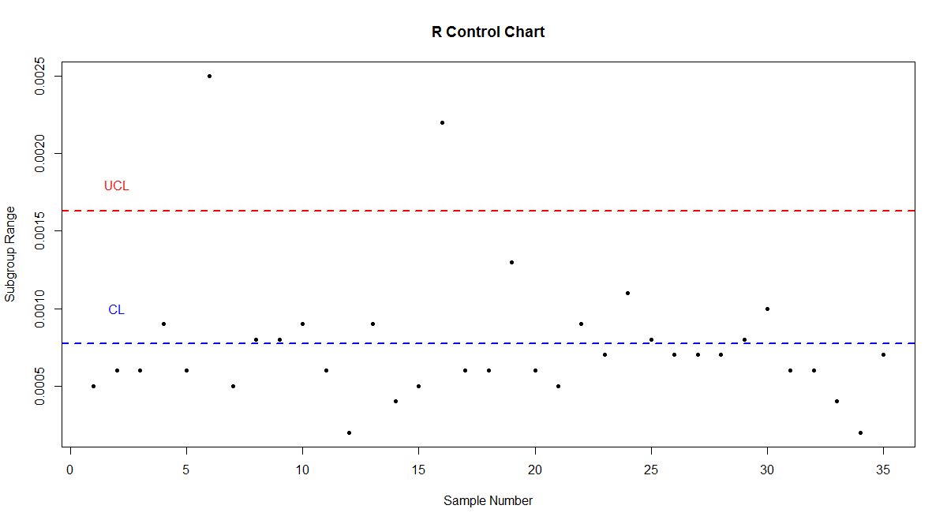

Note that, specific to these subgroups, we indeed have an assignable cause of variation (i.e. absence of regular operator). Therefore, we need to remove these subgroups from consideration and recalculate the control limits. By removing those subgroups where the sample range exceeds the control limits, we obtain;

$\overline{\overline{X}}=3.520024$ and $\overline{R}=0.0006757$

Therefore, based on this, the new control limits for R-chart would be;

$UCL_{R}=D_{4,5}\overline{R}=2.114×0.0006757=0.001428552$

$LCL_{R}=D_{3,5}\overline{R}=0×0.0006757=0$

And $CL_{R}=\overline{R}=0.0006757$.

Now note that, none of the subgroups has ranges outside the new control limits.

Similarly, we obtain the control limits for $\overline{X}$-chart as follows;

$UCL_{\overline{X}}={\overline{\overline{X}}+A}_{2,5}\overline{R}=3.520024+0.577×0.0006757=3.520414$

$CL_{\overline{X}}=\overline{\overline{X}}=3.520024$

And $LCL_{\overline{X}}=\overline{\overline{X}}-A_{2,5}\overline{R}=3.520024-0.577×0.0006757=3.519634$

However, we have again two subgroups to be outside the control limits for $\overline{X}$ chart, but not by a “large” amount. But, we have an assignable cause of variation i.e. startup of boring station as possible reason. Therefore, we need to recalculate the control limits again, now removing those two subgroups.

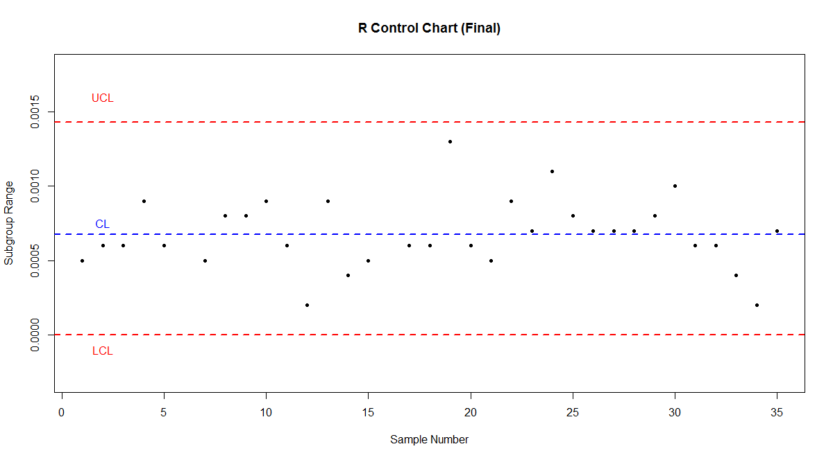

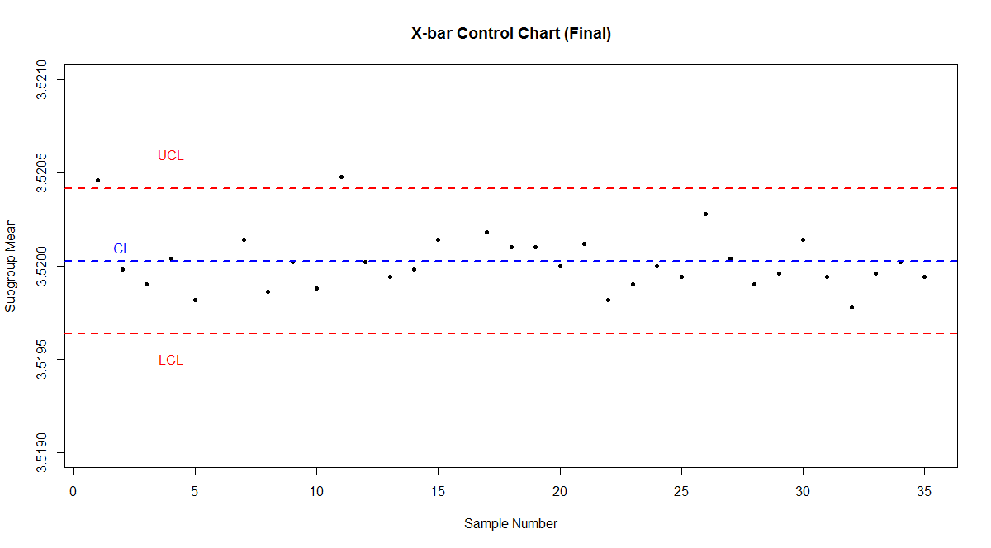

Removing those two subgroups, and recomputing the all sample mean and ranges, we obtain;

$\overline{\overline{X}}=3.519995$ and $\overline{R}=0.000683871$

Similar as before, we finally obtain the control limits for R-chart as;

$UCL_{R}=D_{4,5}\overline{R}=2.114×0.000683871=0.0014457032$

$LCL_{R}=D_{3,5}\overline{R}=0×0.000683871=0$**and $CL_{R}=\overline{R}=0.000683871$.**

Similarly, we obtain the control limits for $\overline{X}$-chart as follows;

$UCL_{\overline{X}}={\overline{\overline{X}}+A}_{2,5}\overline{R}=3.519995+0.577×0.000683871=3.520389$

$CL_{\overline{X}}=\overline{\overline{X}}=3.519995$**and $LCL_{\overline{X}}=\overline{\overline{X}}-A_{2,5}\overline{R}=3.519995-0.577×0.0006838=3.5196$**

We note that, none of subgroup’s mean or range now violates the control limits. Hence, we can adopt this for current use as the trial control limits.

The final charts are given in the following figures.

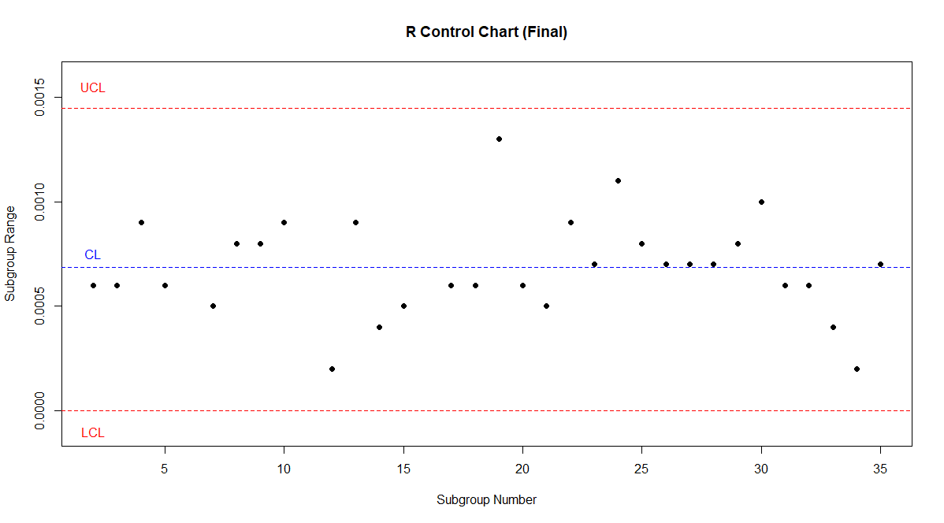

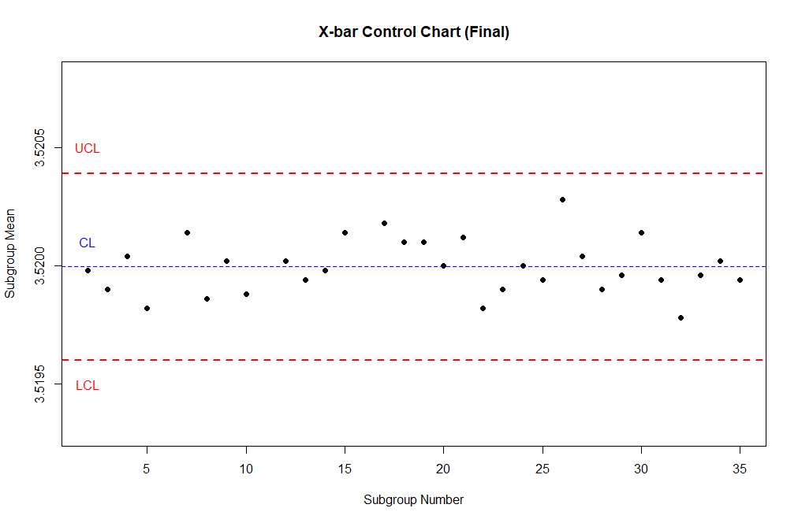

! THANK YOU !